**Group 7 - Final Project**

**App Name and Slogan:**



**Members:** Armon Duncan, Alleef Zettal Bin Ali, Phone Pyae, and Dbjhane Varron

**What is MuseMate?**

MuseMate is a mobile app that helps people learn music in a fun and easy way. It uses games, simple lessons, and practice tools to make learning music interesting. The app is for anyone who wants to get better at music, whether you are just starting or already know a little.

**What is new about MuseMate?**

* Lessons are like games, so learning is never boring.
* You get instant feedback when you practice, so you know if you’re doing it right.
* The app changes and adapts to how you learn best.
* You can use touch, sound, and fun visuals to learn.

**Who is MuseMate for?**

* People who are new to music or have some experience.
* School students learning music.
* Anyone teaching themselves music at home.

**Who will find it helpful?**

* People who want learning to be fun, not stressful.
* Visual learners (who like to see things) and auditory learners (who like to hear things)
* People who don’t have or cannot afford a music teacher.

**How do you use it?**

* Swipe to navigate between lessons.
* Do quick quizzes and exercises, and get feedback right away.
* The app changes to fit your level and helps you improve.
* Listen to sounds, record your own music, and get tips.

**What will happen if you use MuseMate?**

* You will learn music faster, better and the app makes learning music fun.
* You will want to practice more often.
* You can see your progress and feel proud.
* Works for people who like to see or hear things.
* No pressure- learn at your own pace.
* Great for learning by yourself or with a group.

~.~.~.~.~.~.~.~.~.~.~.~.~.~.~.~.~.~.~.~.~.~.~.~.~.~.~.~.~.~.~.~.~.~.~.~.~.~.~.~.~.~.~.~.~.~.~.~.~.~.~.~.~.~

**Design Features (Idea)**

1. **Landing Page:** App introduction, key benefits, and sign-up/login options.
2. **Login/Register Page:** Secure user authentication and account management, includes forget Password.
3. **Home Page:** Personalized dashboard showcasing:

* Recently viewed lessons
* Practice reminders
* Progress summaries
* New content highlights
* Instrument-specific learning paths
* Mini-Game Arcade Access

1. **Lessons** (Core learning modules):

* **Piano/Keyboard**: basic chords and scales, playing melodies, accompaniment techniques, advanced repertoire, and lessons on specific genres (shows different genres and music sheets for users to follow).
* **String Instruments** (Guitar, Ukulele, etc): basic chords and strumming pattern, fingerpicking techniques, and lessons on specific genres (shows different genres and music sheets for users to follow).
* **Drums**: basic beats and fills, coordination exercises, reading drum notation, and lessons on specific genres (shows different genres and music sheets for users to follow).

1. **Mini-Game Arcade**: A section for interactive music games

* **Game selection**: browse available games based on skill level or instrument.
* **Game instruction**: clear guidelines for each game.
* **In-game UI**: simple and engaging interface during gameplay.
* **Scoring system**: Real-time feedback on player performance.
* **Score Display**: Immediate display of score upon game completion.
* **Performance Analysis**: breakdown of accuracy, speed, and areas for improvement.
* **Ranking update**: show how the score affects the player’s ranking on leaderboards.
* **Replay/next game options**: option to play again or move to another game.

1. **Ranking/Leaderboard:**

* Global Leaderboard: ranked by instrument and score.
* Friends Leaderboard: Compare scores with friends and contact, and challenge friends to beat your scores.
* Personal best: track your progress across different mini-games, and display your top scores and performance metrics.
* Rewards and Achievements: badges based on leaderboard performance and lesson achievements, and incentives to climb the ranks and improve scores.

1. **Practice Tools**:

* Metronome with adjustable tempo and time signatures.
* Tuner for various instruments.
* Chord library with visual diagrams.
* Recording feature for practice evaluation and sharing.

1. **Progress Tracker**: Visual Analytics displaying learning milestones, practice time, areas for improvement, and overall music growth.
2. **Profile**: User settings, learning preferences, goals, achievements, and community connections (following, followers, friends).
3. **Settings**: options to adjust audio levels, interface appearance, notification preferences, and other app customizations.
4. **Forget/New Password** - provides a way for users to access their account if they forget their password. Allows user to create new password in case they forget their password or their account was hacked.

**Design Ideas:**

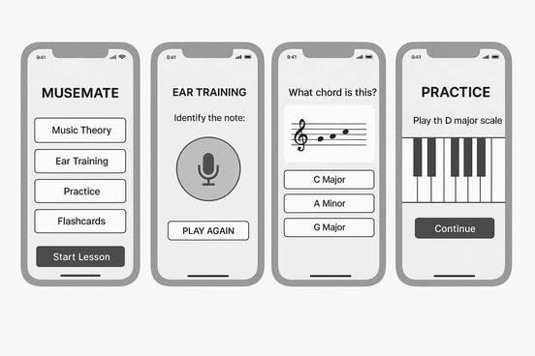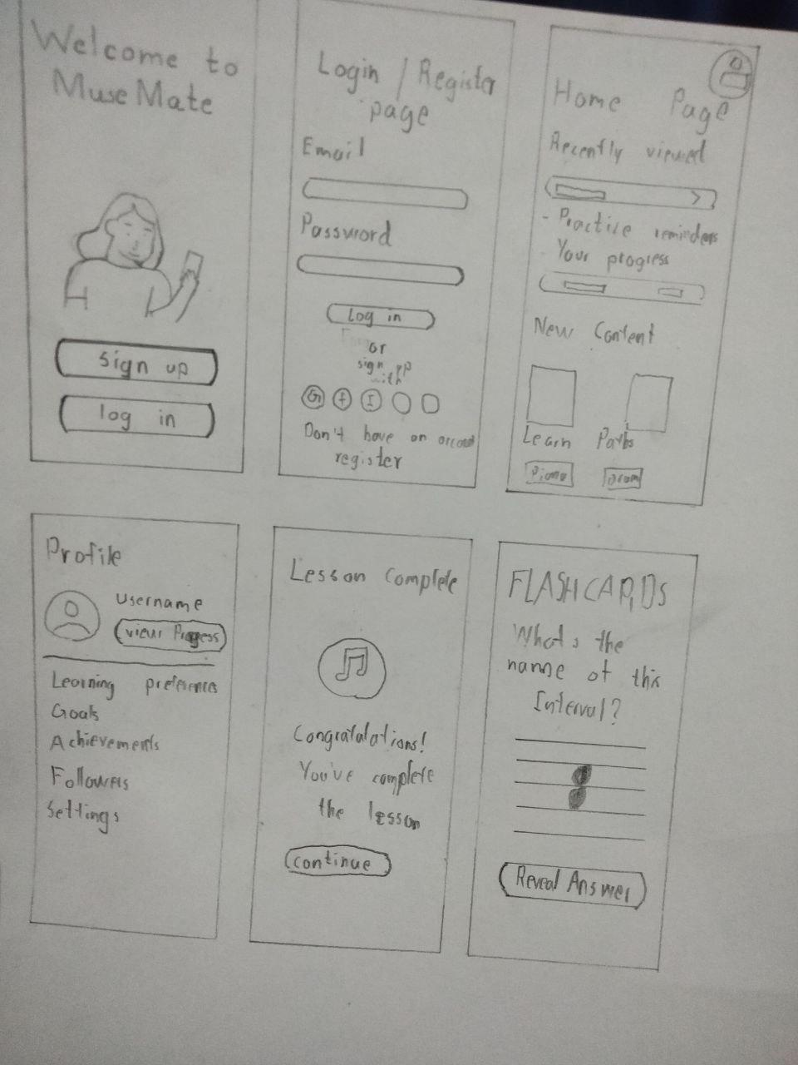

**Accessibility Features:**

* Text-to-speech & voice commands
* Colorblind & high contrast modes
* Large touch targets for easier navigation
* Dyslexia-friendly fonts and font scaling
* Screen reader support (TalkBack & VoiceOver)

**Color Theme**

* #1C2A3A, #FFFFFF, #6883A8

**Roles:**

1. Designers: All Members
2. Documenters: Phone Pyae & Dbjhane

~.~.~.~.~.~.~.~.~.~.~.~.~.~.~.~.~.~.~.~.~.~.~.~.~.~.~.~.~.~.~.~.~.~.~.~.~.~.~.~.~.~.~.~.~.~.~.~.~.~.~.~.~.~

**Design Process:**

**Landing Page** - Dbjhane

* The **landing page** features a clean and minimalist aesthetic that centers around a simple blue color scheme used consistently throughout the site, creating a cohesive and calming visual experience.
* Prominently displayed in the middle of the page are the website’s logo and name, accompanied by the slogan, all rendered in white to provide a striking contrast against the blue background and to enhance readability.
* Just below these branding elements, a clear and inviting button serves as the main call-to-action, guiding users directly to the login page.
* The overall layout is intentionally uncluttered, with ample white space that allows each element to stand out, ensuring visitors’ attention is drawn to the core message and the next step in their journey. This thoughtful design approach not only makes the landing page visually appealing but also aligns with best practices by focusing on simplicity, strong visual hierarchy, and an obvious path forward for users.

**Login In Page** - Phone Pyae Kyaw

* The **Login Page** of the MuseMate app is designed to provide a smooth and welcoming experience for returning users. At the top of the screen, users are greeted with the MuseMate logo and the phrase “Welcome Back,” followed by a short encouraging message.
* Below the welcome message, users are given the option to log in using their Google account through a “Continue with Google” button, offering a quick and secure alternative to traditional login.
* For users who prefer standard login, two text input fields are available. One for the email address and one for the password. These fields are styled with a dark background and blue accent borders helping guide the user’s attention. If a user forgets their password, there is a small link beneath the password field labeled “Forgot password?” which leads them to a password recovery process.
* The “Log in” button is placed below the input fields. It uses a clean and bold design to help users find it easily, tapping on mobile devices. At the bottom of the screen, a line of text shows new users who don’t have an account to sign up, with “Sign up” styled as a clickable link that redirects them to the registration page.
* This page uses a deep navy background with white and soft blue accents, making the text easy to read while maintaining a modern and musical-themed aesthetic. The font used throughout the page is either *Poppins* , known for their clarity and friendliness in mobile interfaces. When the user successfully logs in, they are taken to the app’s **Home Page**.

**Sign Up Page** - Phone Pyae Kyaw

* The **Signup Page** is made to help new users join the MuseMate community with ease. The page features a clean white background and begins with a welcoming header that reads “Sign up,” followed by a friendly subheading.
* The form includes input fields for the user's name, email address, password, and a confirmation of the password. Each field is clearly labeled and uses a light gray background with rounded corners to enhance readability and a sense of softness. The inputs are spaced evenly to maintain a clean and uncluttered layout.
* Once all fields are completed, users can tap the “Sign up” button, which is styled in dark navy with white bold text for strong contrast and visibility. This button provides a clear call to action and is placed in a comfortable position to reach.
* Below the sign-up form, users who already have an account are reminded with the message: “Already have an account?” followed by a “Login” link that redirects them back to the login page.
* The font used for this page is consistent with the login page, using *Poppins* to ensure a modern and user-friendly reading experience. After completing the sign-up process, users are directly brought to the **Home Page** to start using the app.

**Home Page** - Phone Pyae Kyaw

* The **MuseMate Home Page** serves as the personalized dashboard for the user. It displays a welcome message followed by easy access to essential features. The page is structured into multiple interactive components that help the user navigate through lessons, track their progress, and engage with practice tools or games.
* At the top of the screen, the user avatar/profile icon appears in the upper-right corner. When tapped, it opens the user profile screen where personal settings can be viewed and edited.
* Below the greeting, the Practice Lesson card displays
* The Practice Reminder card shows whether the user has a reminder set for the day. Tapping it leads to the Practice Reminder screen where users can set or edit practice notifications and goals. The Reminder screen allows users to set a daily practice reminder. They can choose a specific time using the "Customized your time" section and select which days they want to be reminded. After setting preferences, the user taps "Save" to confirm. A bell icon at the top provides a visual cue for notifications.
* The Your Progress card displays a summary of lesson streaks or levels completed. Tapping it directs the user to a Progress Tracker page where they can review their learning charts, and streak.
* Under the Mini-Game Arcade section, two game buttons, Chord Challenge and Rhythm Hero are shown. Tapping either launches the selected mini-game. The user enters the game environment, plays, and receives the scores.
* At the bottom, the New Courses section presents instrument-specific paths like String, Piano, and Drum. When a user taps on one of these, they are taken to a dedicated course page for that instrument. There, they can find available lessons by genre, level, and learning style.

**Lessons** - All Members

* **Landing Page** (Dbjhane): There are three pages connected to the Lesson section’s landing page. On the landing page, you’ll find two images, each labeled with a category: String Instruments (guitar, violin, cello, and ukulele) and Brass & Percussion (tuba, drum, and piano). Each image includes a button that leads to a dedicated page displaying all the instruments available within the selected category. Dbjhane has maintained a simple and consistent design, similar to other landing pages, by incorporating images, headers, subtitles, and buttons. The layout of the images is adjusted based on the number of buttons required on each page, ensuring a clean and user-friendly experience.
* **Piano** (Phone Pyae): This page offers an interactive experience for learning piano basics. At the top, there is a virtual keyboard where users can tap on individual keys to hear the sound and visually associate notes with their position on the music staff. The stave displayed above updates to reflect the key being played, helping reinforce learning visually and actually. A tab-based lesson section follows starting with an introduction and basics of the piano. Below, learners can access and scroll through beginner friendly sheet music which they can view and practice with the interactive keyboard. Every tap on the piano keys reinforces note recognition and muscle memory.
* **Drums** (Phone Pyae): This page is also highly interactive and allows users to explore drum sounds by tapping on various drum elements. The drum kit includes snare, toms, hi-hats, crash, ride and a kick drum. Each drum part plays its corresponding sound when tapped, allowing users to explore rhythm freely. Below the virtual drum interface. There is a structured “Drum lesson” section which offers categorized lessons for beginner level. Tapping on any of these buttons launches the selected tutorial, guiding the user through rhythm exercise and drumming techniques. This page is designed to help users feel the rhythm interactively before diving into structured learning.
* **Guitar & Ukulele Pages** (db): Both of these instruments follow a similar layout on their landing pages. At the very top, the page displays the instrument’s title. Directly below, users can see a list of songs they have already tried, as well as the courses available to them based on their current skill level. Further down, there is an image accompanied by a title and description, which provides information about the course, the user’s proficiency level, and the number of lessons included. This section is followed by a button for easy navigation. Beneath this, the page displays the song(s) the user has previously attempted. Users can click on these songs to view the corresponding chords and lyrics. Below this section, there is also a list of easy songs that users can learn and play. When a course is selected, the user is taken to a new page where they are taught basic chords and can practice until they achieve mastery. Upon completing the course, users receive a congratulatory message and are shown a selection of songs they can now play using the new chords they have learned.
* **Violin** (jayjay):
* **Cello** (jayjay):
* **Tuba** (Armon):

**Mini Game** - Armon

**Ranking** - Armon

**Practice Tools** - Dbjhane, Alleef

* The **Practice Tools Landing Page**, designed by Dbjhane, offers a straightforward and visually unified introduction to the site’s core features. The page showcases four distinct photos, each accompanied by descriptive text beneath them, representing the available tools: metronome, tuner, chord library, and a recording area where users can capture their voice or instrument playing. Consistent with the rest of the site, the color scheme is maintained throughout, reinforcing brand identity and ensuring a cohesive look. Each photo is enhanced with a subtle drop shadow, adding a sense of depth and making the visuals stand out against the clean background. Both the images and their corresponding text are fully interactive, allowing users to easily navigate to the respective tool pages with a single click. This simple, organized layout not only highlights the tools at a glance but also aligns with best practices for landing page design by providing clear navigation, visual appeal, and an intuitive user experience.
* The **Tuner Practice** **Tools** were collaboratively developed by Dbjhane and Alleef, with Dbjhane focusing on the Guitar and Ukulele tuners and Alleef handling the Cello and Violin instruments. Both designers used geometric shapes to visually recreate the running head and head pegs of each instrument, ensuring that the interface not only looks familiar to musicians but also clearly displays the respective chords or tuning notes required for each instrument. To enhance usability, they incorporated a bar at the top of the interface that helps users determine if their instrument is in tune, as well as indicators for flat or sharp notes, providing real-time visual feedback similar to those found in commercial electronic tuners. Additionally, there are conveniently placed buttons at the top of the page, allowing users to easily select which of the four instruments they wish to tune. The page title maintains consistency with the rest of the site by using the same size, color, and style, contributing to a cohesive user experience across all pages.
* The **Metronome** was created by Dbjhane, who applied the same design principles used in the tuner tools by utilizing geometric shapes to construct the visual representation of the metronome, all while maintaining the site’s cohesive color scheme. The interface prominently displays the beats per minute (BPM), making it easy for users to set and monitor their tempo. Above the metronome, there are intuitive bars that allow users to adjust and view key settings such as volume, beat, and note, ensuring a functional and user-friendly experience that aligns visually and interactively with the rest of the platform.
* The **Chord Library** was a collaborative effort between Dbjhane and Alleef, each bringing their own strengths to the feature’s design and functionality. Dbjhane was responsible for the landing page, which adopts a straightforward and visually clean approach by using photos paired with text labels to clearly indicate each available instrument. The design concept here mirrors the style of the Practice Tools landing page, ensuring consistency across the app’s interface. Alleef focused on developing the individual chord pages for guitar, violin, and piano. On these pages, he utilized shapes and lines to accurately represent the chord diagrams for each instrument, making it easy for users to visualize finger placements and chord structures. This thoughtful combination of intuitive navigation on the landing page and clear, instrument-specific chord illustrations provides users with a seamless and accessible way to explore and learn chords for multiple instruments, all while maintaining a cohesive visual identity throughout the Chord Library section.
* The **Record Page** was designed by Dbjhane and provides users with a streamlined space to capture and track their musical progress. At the top, there is a dedicated recording area where users can easily record new pieces or practice sessions. Below this, a comprehensive list displays all saved recordings, showing essential details such as the name of each recording, the date and time it was made, and its duration, making it simple for users to review their work at a glance. At the bottom of the page, users will find intuitive controls for creating new recordings, including a field to name their track, play and stop buttons for managing the recording process, and a time counter for precise tracking. This thoughtful layout ensures that users can effortlessly document, organize, and revisit their musical journey.

**Progress Tracker** - Phone Pyae Kyaw

* This page gives users a detailed summary of their learning activity. At the top, it displays the user's current streak. Below that, it shows the total practice time and the number of lessons completed. At the bottom, a simple line graph visualizes the user's practice activity over time, helping them see progress trends.

**Profile** - Phone Pyae Kyaw

* On this screen, users can update their personal details. Editable fields include name, email, password, date of birth, and country/region. After editing, pressing **"Save"** updates their information. The avatar at the top may also be editable when tapped.

**Settings** - Phone Pyae Kyaw

* This screen acts as a central place for managing personal preferences. It shows the user’s avatar and email, followed by options:
* **Edit Profile**: Opens the profile screen.
* **Language**: Opens the language selection screen.
* **Notifications Toggle**: Allows the user to enable or disable app notifications.
* **Log Out**: When tapped, prompts the user with a confirmation to sign out.

### **Language Page**

* This screen lets users select their preferred language. Suggested options like English (US) and English (UK) are at the top. Other options include Arabic, French, Hindi, Italian, Mandarin, Russian, and Spanish. Users tap the radio button next to the desired language to apply the change.

### **Log Out Confirmation**

* When the user taps Log Out from the settings page, a confirmation screen appears asking:  
   "Are you sure you want to log out?"  
   Two buttons are presented.

**Forgot Password/New Password** - Dbjhane

* The **"Forgot Password"** feature is easily accessible from the login page by clicking the “Forgot password?” link. Once selected, you’ll be directed to a page where you can enter your email address or username. After clicking "Continue," you’ll proceed to a secure page where you can create a new password and confirm it by re-entering it. Upon submitting your new password, a confirmation page will appear to let you know your password has been successfully changed, along with a button that conveniently takes you back to the login page.
* Throughout this process, all three pages maintain a consistent and visually appealing design: a blue background with a white rectangle overlay that highlights the main content. Each page features clear titles, straightforward instructions, and input fields for your information. The action buttons are styled to match the blue color scheme, ensuring a cohesive and user-friendly experience from start to finish.

**Navigation** - Phone Pyae

~.~.~.~.~.~.~.~.~.~.~.~.~.~.~.~.~.~.~.~.~.~.~.~.~.~.~.~.~.~.~.~.~.~.~.~.~.~.~.~.~.~.~.~.~.~.~.~.~.~.~.~.~.~

**Form Feedback:**

* Clients:
* Feedback:

**Form Link:**

<https://docs.google.com/forms/d/e/1FAIpQLSfsXAgngOC7AMIZnZMFA5EY60UL1-OpQzrgVnm19Y0OK1iUig/viewform?usp=header>

**Figma Link:**

<https://www.figma.com/design/ATA2eJKAKRFfYTMO7JD6Og/Untitled?node-id=0-1&p=f&t=ia3fQjv171kwjIzl-0>

**Canva Link:**

<https://www.canva.com/design/DAGmgi2F0EQ/poOob1WUa8rJZEgtKpDMOQ/edit?utm_content=DAGmgi2F0EQ&utm_campaign=designshare&utm_medium=link2&utm_source=sharebutton>